## Seminar Report on Child and robot interaction

## Submitted by

## Yash Sandesh Malwade

**INDEX**

|  |  |  |
| --- | --- | --- |
| Chapter No. | Content | Page no. |
| 1. | Abstract | 1 |
| 2. | Introduction | 2 |
| 3. | Literature Review | 4-5 |
| 4. | Related work | 7 |
| 5. | Experiment 1  Participants | 8 |
| 6. | Procedure | 8 |
| 7. | Results | 11 |
| 8. | Perception of children’s emotional responses | 12 |
| 9. | Experiment 2  Method  Participants  Stimuli  Procedure | 12 |
| 10. | Results | 13 |
| 11. | Observational analysis of children’s non-verbal behavior | 13 |
| 12. | General discussion and use | 14-15 |
| 13. | Conclusion | 16 |
| 14. | References | 17 |

**List of Figures**

|  |  |  |
| --- | --- | --- |
| Sr. No. | Name | Page No. |
| 1. | An interactive session with robot | 9 |
| 2. | Experimental setup | 10 |
| 3. | Graphical representation | 11 |
| 4. | Pie charts | 14 |

**List of Tables**

|  |  |  |
| --- | --- | --- |
| Sr. No. | Name | Page No. |
| 1. | Number of participants in experiment | 6 |
| 2. | Contingency table of the perceived robot's behaviour. | 8 |

**List of Short Forms**

|  |  |
| --- | --- |
| Short Forms | Full Forms |
| CRI | Child robot interaction |
| HRI | Human robot interaction |

**ABSTRACT**

The design and use of social robots addressed to the children population is a

growing research field. The understanding of how the children react, or what

are their preferences towards a robot with different styles of interaction is

an important aspect to maximise the construction of a social bond between

the robot and the child.For effective child education, playing games with a

social robot should be motivating for a longer period of time. One aspect that

can affect the motivation of a child is the difficulty of a game. The game

should be perceived as challenging, while at the same time, the child should be

confident to meet the challenge. Children afforded robotic entities less moral

concern than living entities but afforded them more moral concern than

nonliving entities, and these effects became more pronounced with age.

Children’s tendency to ascribe mental life to robotic and nonliving entities

(but not living entities) predicted moral concern for these entities.

**INTRODUCTION**

Some years ago, the development of robots for industrial applications such as manufacturing, assembly, packing and transportation had the main objective to release human operators from dangerous, risky or repetitive tasks. Different research areas including kinematics, motion planning, and the employment of different control and artificial intelligence techniques contributed to the achievement of this objective . In more recent years, the main aim of a new generation of robots is to act as partners, assistants or companions of humans sharing common place e.g. in a domestic home environment. This objective has fostered the collaboration between different disciplines such as psychology, linguistics, sociology, ethology and others in order to design better social robots that facilitate a continuous and long-term interaction with humans. These studies are the basis of a relatively new field of research known as Human-Robot Interaction(HRI) where the -verbal and non-verbal- interaction with people is a defining core ingredient. For children, playing educational games with a social robot can be a fun way to learn, to take their mind of their current situation, or simply for the sake of enjoyment. Within the ALIZ-E and PAL projects, educational games are used to teach children with diabetes how to manage their chronic illness. A robotic tutor's primary purpose is to instruct and guide children within specific learning activities. If this purpose is jeopardized for whatever reason, problems may arise that lead to breakdowns in interaction , where children, e.g., grow disengaged or unable to progress in the task.These studies include for example how children attribute features of friendship to a robot the influence of culture (individualistic vs. collectivistic) in child-robot interactions the effects produced in the children when a robot displays familiarity (through verbal communication) during interactions the evaluation of children's expectations (before) and subsequent satisfaction (after) the interaction with a robotic tutor or the children's perceived support from an empathic robot .The primary aim of the current study, therefore, was to examine children’s perceptions of the moral worth of robots.**Literature Review**

|  |  |  |  |  |
| --- | --- | --- | --- | --- |
| **Sr.**  **No.** | **Title of research paper** | **Name of Author** | **Journal/Conference name with year of publication** | **Summary** |
| 1 | A Child and a Robot Getting Acquainted – Interaction Designfor Eliciting Self-Disclosure | Mike Ligthart,  Timo Fernhout,  Mark A. Neerincx  And  Kelly L. A. van Bindsbergen | AAMAS 2019, May 13-17, 2019, Montréal, Canada | We evaluated a robot that autonomously engaged with children in a getting acquainted interaction. We designed five structured dyadic interaction design patterns. Results show that the design patterns allow the robot to effectively elicit and process children’s self-disclosures by asking a combination of closed-ended, open-ended, and pseudo-open-ended questions. If speech recognition fails, the touch modality proved to be an effective back-up. Due to the six-step turn taking pattern children quickly pick up on how to effectively talk to the robot. Results show that improvements can be made by refining the timing of backchannels and adding a repair mechanism for incorrectly recognized speech. |
| 2 | Breakdowns in children's interactions with a robotic tutor: Alongitudinal study | Sofia  Serholt | Department of Applied Information Technology, University of Gothenburg, Forskningsgången 6, 412 96, Gothenburg, Sweden | Results:  There are many visions for the educational benefit of CRI, such as robots holding the ability to interact with children in the real physical world, facilitating learning ,personalizing education and so on and so forth. even assert that there are technical ways of circumventing a robot's lack in perception such that children can be fooled into believing that a robot actually understands them similar to how a human interactant would. However, when looking at the state of the actual, it is clear that CRI in education is not as straightforward. Fooling children into believing that a robot understands them does not offer much consolation when there is a structured task to be carried out,or a fruitful collaboration to be upheld. Like in HCI, CRI breaks down when expectations go unmet, i.e., that robots should have humanlike perception and communication abilities. Of course, structured tasks common to CRI scenarios are helpful for increasing the prospect of robots perceiving and responding socially, but even then, it is evidently not enough. |
| 3 | Children’s  perceptions of  the moral worth  of live agents,  robots, and  inanimate  objects | Kristyn Sommer , Mark Nielsen, Madeline Draheim ,Jonathan Redshaw,Eric J. Vanman ,and Matti Wilks | Early Cognitive Development Centre, School of Psychology, University of Queensland, St. Lucia, QLD 4072, Australia | The goal of this study was to determine the effectiveness of a Bayesian model to estimate child’s skill level for playing a game with a robot and personalising the game play to keep children motivated. An important constraint was that only a small number of interactions was provided for this model. While the estimates of the Bayesian rating system were not accurate enough to increase the percentage of correct answers to 70%, the Bayesian rating system was still able to quickly assess the child’s skill level and adapt the difficulty of the game accordingly. Providing the optimal challenge by actively increasing the percentage of correct answers to 70% is likely not feasible without access to enough data to reliably calibrate the item rating. Instead, it may be attractive to capitalise on the properties of social robots, like our tendency to project social qualities to the behaviour of technology and have the child compete with the robot. In this case, the child can answer only 50% of the items correctly, but still win the game by outperforming the robot. In this scenario, it may be that the child will not perceive the items as being too challenging. |

**Related work**Educational robots are robotic systems that can support children in a learning task by serving as tutor teaching assistant or as a peer . Using the robot as a tutor or peer can be especially beneficial, as it can provide children with one-on-one tutoring which can increase learning gains. For the robot to be effective in supporting children in learning a task, it will need to personalise it’s social behaviour and the learning content to the user. For example, social behaviours that can influence learning include the use of gestures socially supportive behaviours,or personalised language. Personalising the tutoring strategies based on a user’s skill has been shown to improve learning gains. In their study, Leyzberg et al. used two algorithms to model the user’s skill: a simple additive model and a Bayesian network. The former model is susceptible to local maxima and minima, while the latter categorises a skill to be either learned or not learned. Gordon & Breazeal (2015) used a social robot to teach children word-reading skills.

In the related field of computer-based learning, educational computer programs called Intelligent Tutoring Systems(ITS) are developed to give individualised lessons and have shown to be effective tutors (VanLehn, 2011). ITS use student modelling techniques to measure and represent user characteristics (Polson & Richardson, 2013). Estimates of a user’s skill can be obtained via models from the item response theory (IRT). This theory contains a number of statistical models which relate a user’s response to items to a latent trait of the user (Lord et al., 1968). Typically, these models were developed with the assumption that skill does not change over time, which is a reasonable assumption for skills that are learned very slowly, or for short tests.

**Experiment**

Participants:A total of 174 children (78 female, 96 male) aged 6 to 11 (M8.62) participated in the experiment. The number of participants of each age's group is presented in Table . All the participants attend the elementary school (grades first to fifth). The only exclusion criterion was not to have any verbal communication problem due that the participant has to give the instructions to the robot using spoken-based commands. Two elementary schools accepted the invitation to participate: one located in the city, close to the installations of our research institution, and the other located in a small town in a rural area. Due to the location of the two schools, the experiment was carried out in two different places. The first location was a lab inside the installations of our institution where 21 children from the urban elementary school attended to participate. The second location was inside a classroom of the elementary school located in the rural area and 153 children from that school participated in the experiment. The same scenario and procedure were used in the two locations. None of the 174 volunteers fulfilled the exclusion criterion and all of them were included in the experiment.

Number of participants stratified by age.

|  |  |
| --- | --- |
| Age group | No of participants |
| 6 | 32 |
| 7 | 21 |
| 8 | 23 |
| 9 | 30 |
| 10 | 41 |
| 11 | 27 |

**Procedure:**

A dedicated room was reserved in both locations to perform the experiment. The two technicians acting as the Wizard were seated behind the participants to avoid any distraction in the child during the interaction with the robot. The maze was put in front of the participant and the video camera was put in front of the maze to record the facial and body movements of the child. In order to create a more comfortable environment for the children, we decided that couples of friends enter the room. In this way, the participants stay near from his/her friend in the room and not only with the technicians and the facilitator of the experiment, which would cause some suppression in the natural responses of the children towards the robot (see Fig. 3). This decision was adopted after the initial pilot performed during the design stage of the scenario where single children participated in the interactive sessions, and they reported (especially the children under 10 years old) that would feel better with a friend in the room. A random selection was used to select the order that the couples of children entered the experiment's room.

The experiment starts when the facilitator provides the instructions to both children. They were instructed that only one child can interact with the robot at a time, while the other needs to remain seated without speak nor intervene during the interaction for not to confuse the robot. The facilitator explains that once the first child finishes the interaction, then the second child can start his/her turn. After that, the facilitator explains the mission that the children will perform with the robot:

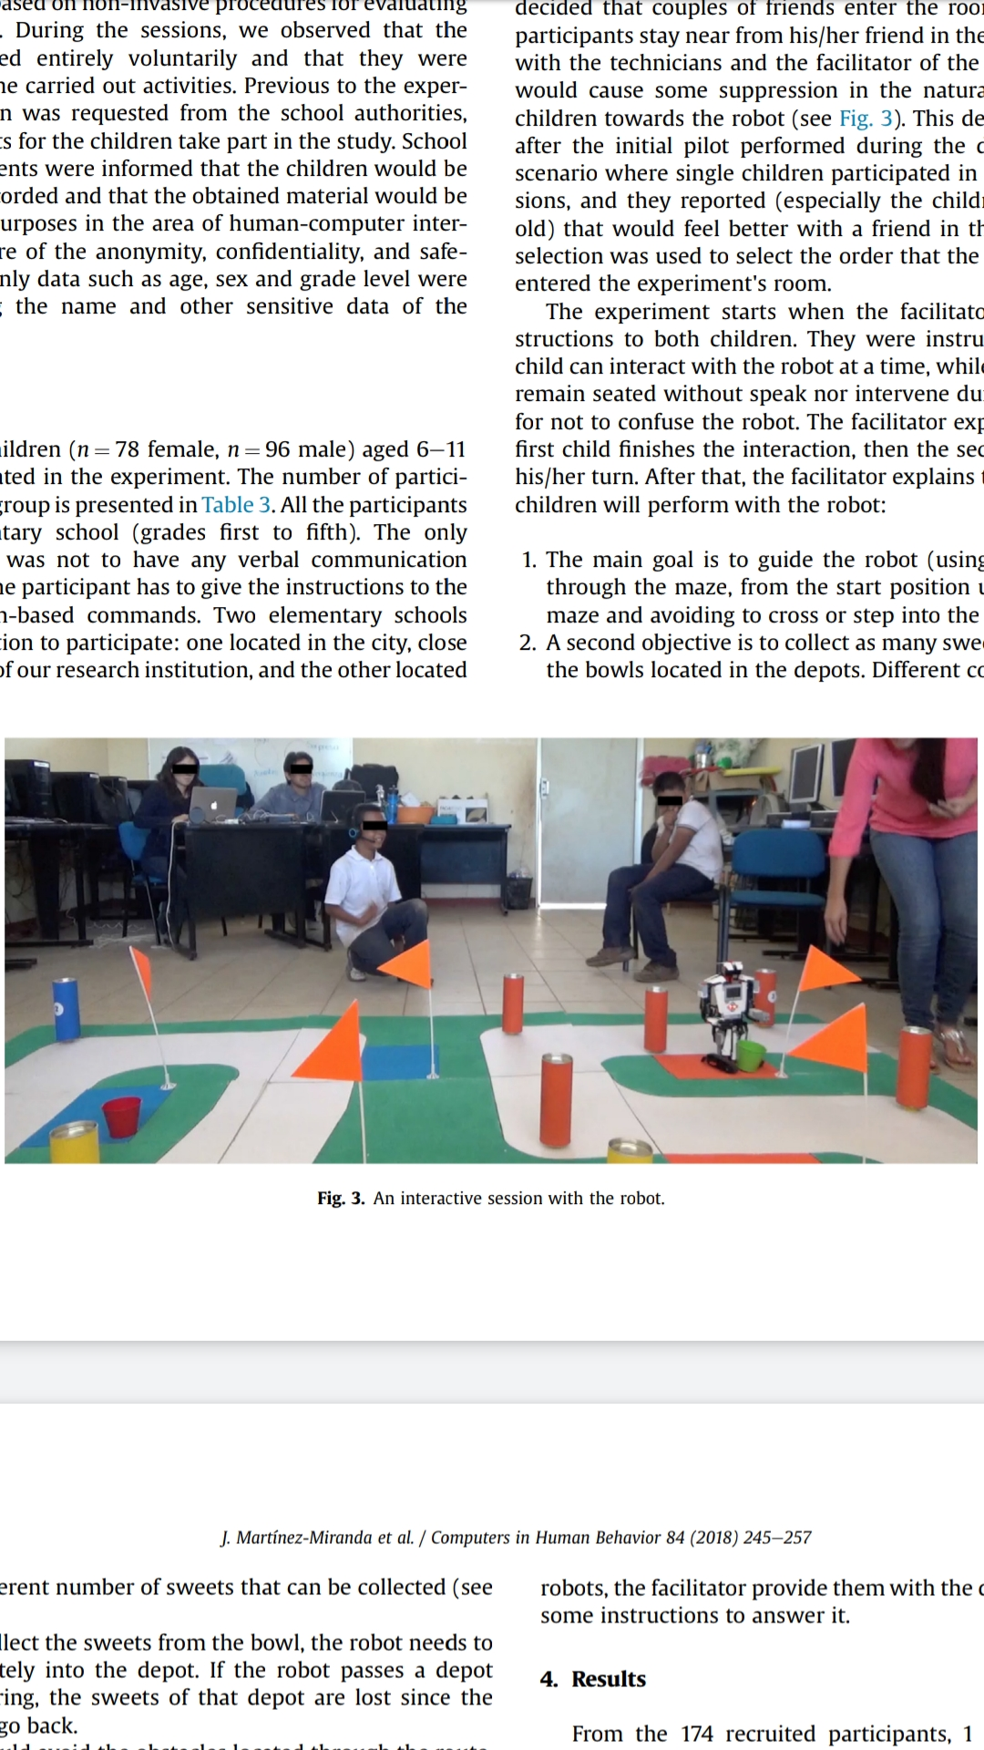

Fig. An interactive session with the robot

1. The main goal is to guide the robot (using voice commands) through the maze, from the start position until the exit of the maze and avoiding to cross or step into the green areas.2. A second objective is to collect as many sweets as possible from the bowls located in the depots. Different colours in the depots represent different number of sweets that can be collected.3. In order to collect the sweets from the bowl, the robot needs to enter completely into the depot. If the robot passes a depot without entering, the sweets of that depot are lost since the robot cannot go back.4. The robot should avoid the obstacles located through the route. If an obstacle is dropped, a number of previously collected sweets are lost depending on the colour of the obstacle.

Contingency table of the perceived robot's behaviour.

|  |  |  |  |  |  |
| --- | --- | --- | --- | --- | --- |
| Question | Responses | Range of age | | | Total |
| 6-7 | 8-9 | 10-11 |
| The noted behaviour in the robot was: | Equal | 6 | 1 | 1 | 8 |
| Different | 42 | 50 | 64 | 156 |
| Total |  | 48 | 51 | 65 | 164 |
| The robot did not follow the instructions because: | I did not speak correctly. | 19 | 19 | 21 | 59 |
| It did not want to follow my instructions. | 29 | 32 | 44 | 105 |
| Total |  | 48 | 51 | 65 | 164 |

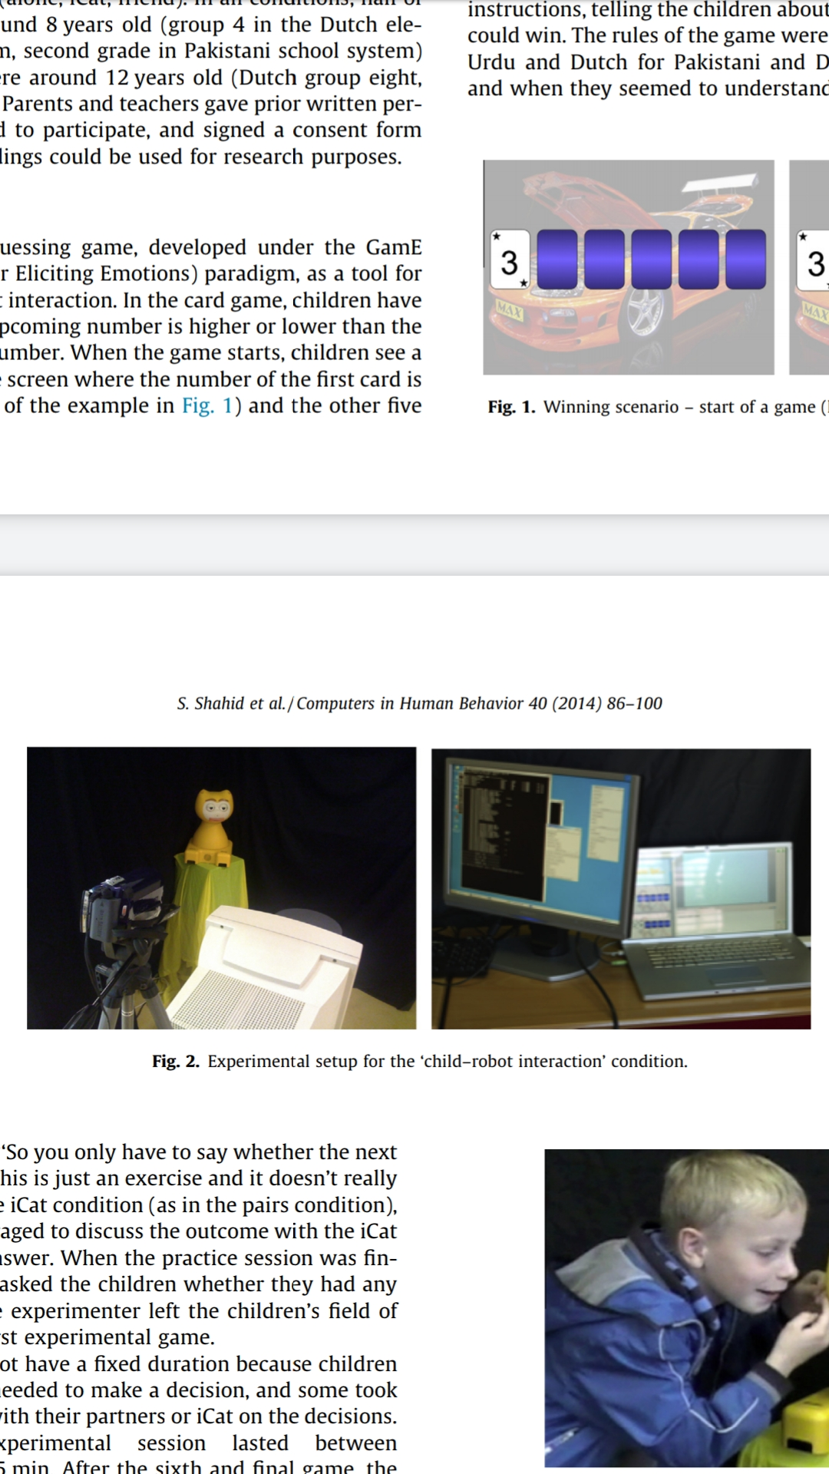Fig. Experimental setup for the child and robot interaction

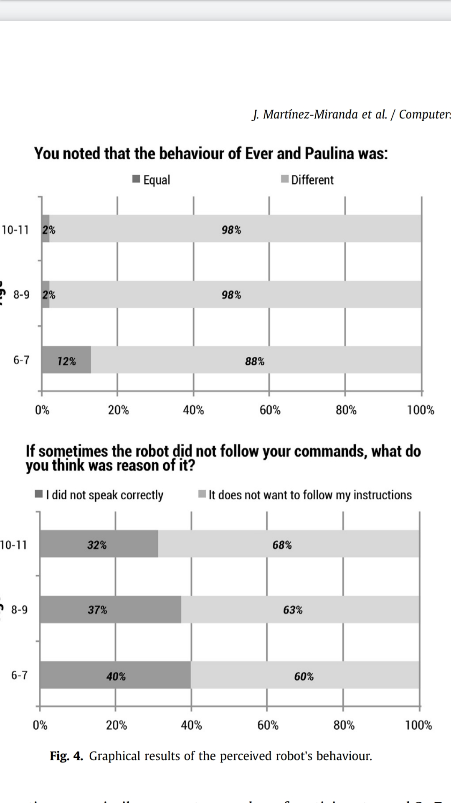

**Results:**

From the 174 recruited participants, 1 child decided not to conclude the session and 9 did not answer all the questions. The data of these 10 participants were excluded from the analysis getting a final number of 164 records to assess. Due that the sample of the participants with a specific age was small, the data were grouped into three ranges of ages as presented in Table 4. To analyse the independence of the age regarding the perceived robot's behaviour, emotional reactions and preferences towards the two robots we conducted a chi-square analysis (p<0:05). Given that the expected frequencies in the contingency table were less than 5 in more of the 20% of the cases, we used Fisher's exact test for each section of the questionnaire.

**Perception of children’s emotional response:**

In the previous section we discussed children’s self-reports on how they appreciated the interaction with the iCat, and compared the results with those obtained from children playing alone or with a friend. During the game playing session, children were also videotaped. These recordings comprise a rich collection of social behavior and of verbal and non-verbal emotional responses to winning or losing a game. In this section we present selected recordings from children (taken from all three conditions) and present them to judges. Their task is to guess whether the child has just won or lost the game. In this way we can objectively estimate the expressiveness of the children in the different conditions; more correct guesses indicate that children are more expressive.

**Experiment 2 :**Method:

Participants:144 Dutch adults participated in the perception analysis as judges, with a roughly equal number of men and women.Stimuli:We randomly selected 80 children who played games with the iCat, 40 Dutch and 40 Pakistani. For comparisons, we also used clips of 144 children from the ‘alone’ and ‘pairs’ condition, which were collected in the earlier study, mentioned in the introduction of this paper. We balanced for age and gender and for each child we chose the first winning game (in which children made a correct prediction for the last card) and the first losing game (in which the final guess turned out to be incorrect) from the video recordings. Furthermore, from the clips of child-pairs, we randomly selected one child from each pair by zooming in on his/her face. In the case of the iCat condition, we also zoomed in on the child’s face so that the iCat was never visible in the stimuli. Half of the children sitting on the right chair and half of the children sitting on the left chair were selected. The video snippets were cut from the moment the final card was turned until the main response of the child was finished.

**Procedure:**Four group experiments were conducted and in each experiment 36 Dutch viewers viewed one set of stimuli. For every experiment, groups of participants were invited into a quite classroom here the computer screen was projected on the classroom wall using a projector. Participants were told that they would see a set of stimuli in which children were showing their emotions after winning or losing a game and that their task was to determing whether the children had just won or lost their game (Fig. shows representative stills from each clip). Each stimulus was preceded by a number displayed on the screen indicating the upcoming stimulus, and followed by a 6 s interval during which participants could fill in their score on the answer form. The actual experiment was preceded by a short training session in which 3 clips were shown.

**Results:**

For measuring the experience of fun after playing games in three conditions (alone, iCat, friend), we used a variant of the ‘funometer’ to assess their experiences. For analyses, scores of fun measurements were mapped on a 1–7 point Likert scale where 1 was no fun at all and 7 represents a lot of fun. To test for significance we conducted a univariate analysis of variance (ANOVA) with three between-subject factors, namely Partner (levels: alone, iCat, friend), Culture (levels: Pakistani, Dutch) and Age (levels: 8 years, 12 years) and with the mean fun score as the dependent variable. The Bonferroni method was used for pair-wise comparisons.

**Observational analysis of children’s non-verbal behavior:**The perception tests clearly showed that children were more expressive when playing a game with an iCat than when playing the game alone, although they were still more expressive when playing with a friend. In this section, we describe a detailed observational analysis of the children’s non-verbal behavior in the various conditions. This was partly done to find out what kinds of features participants of our perception tests may have used as cues in their judgments, but also to gain insight into culture specific behaviors that children display in various game contexts.

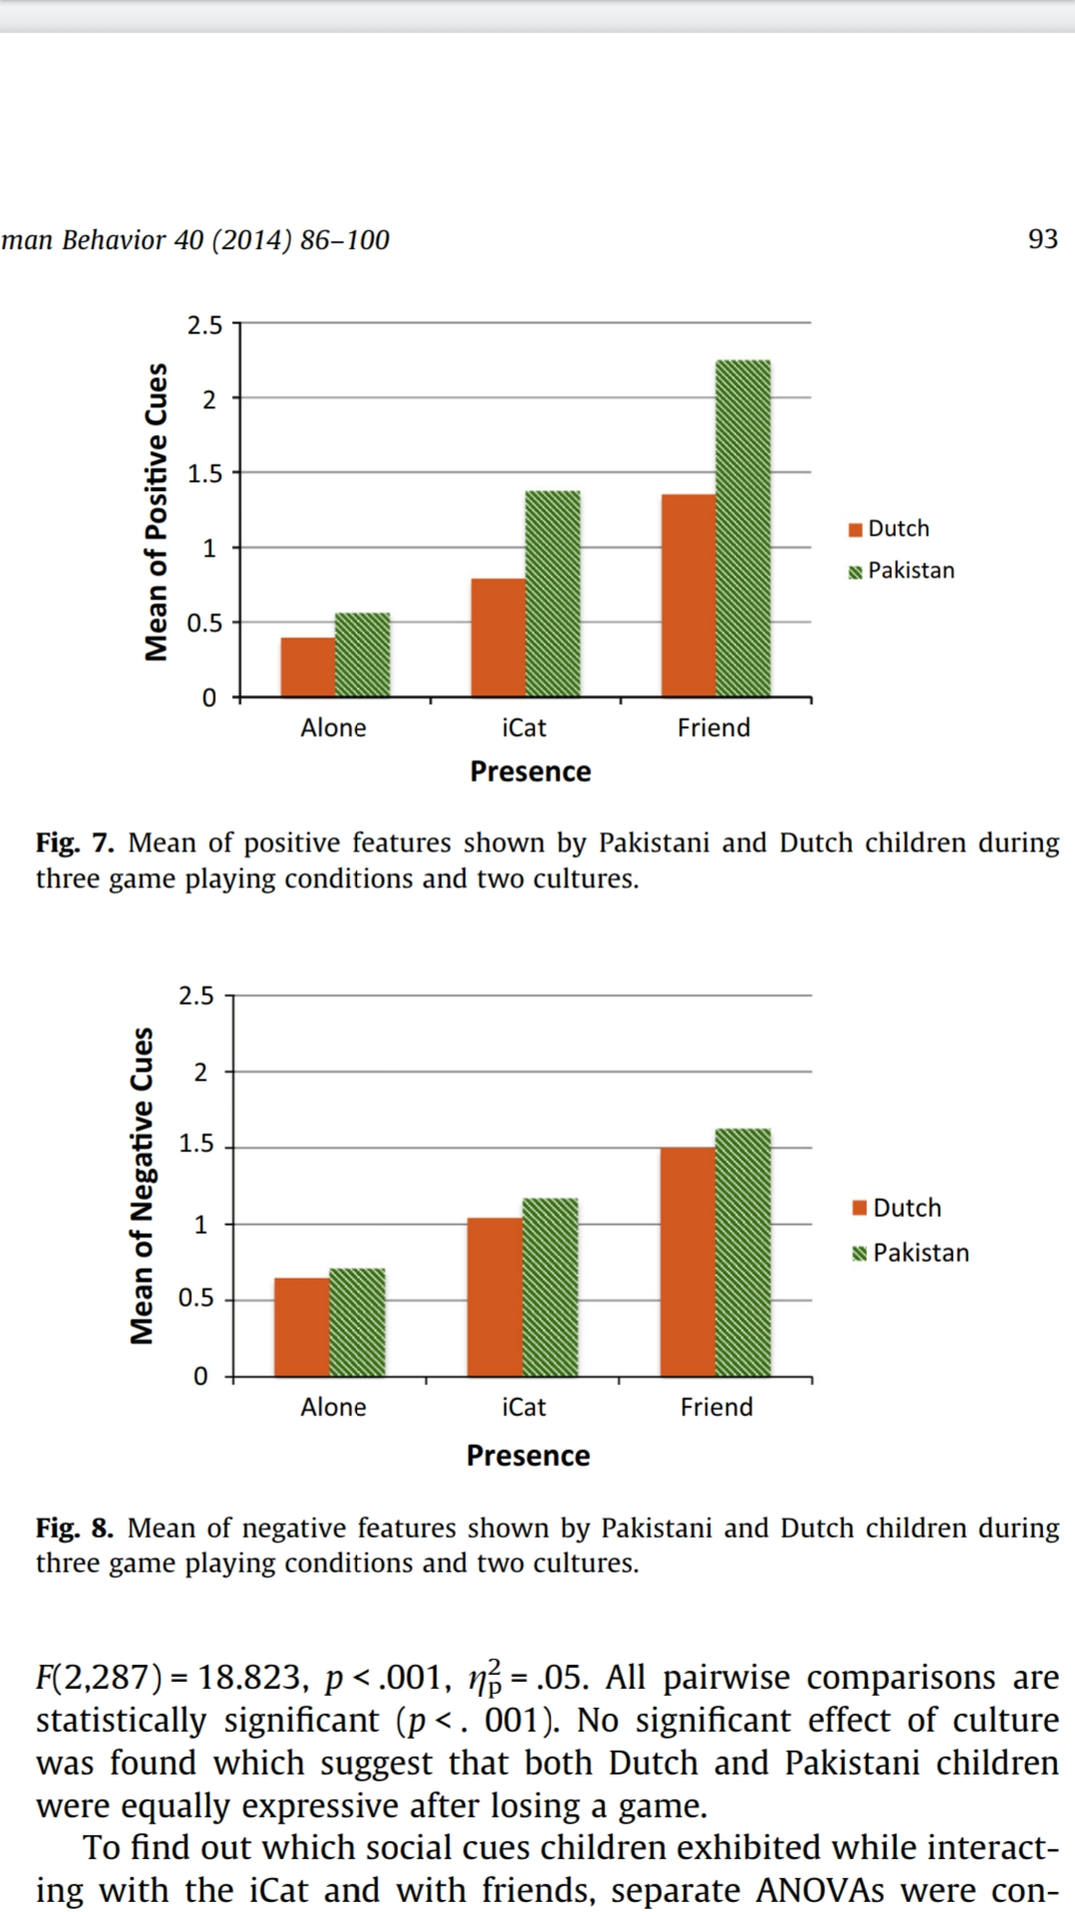

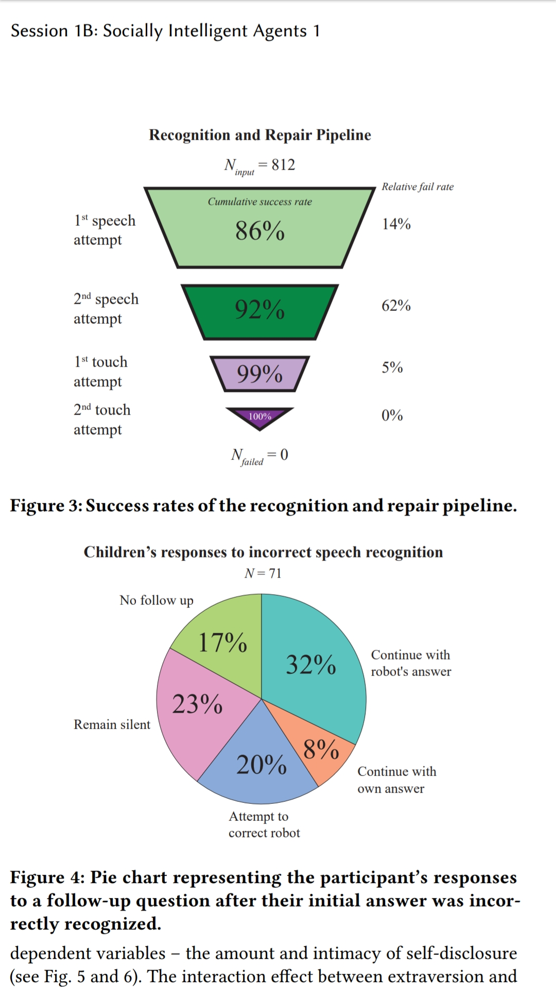

**General discussion:**

In the present study, we studied how children of different age groups and belonging to different cultural backgrounds experience playing a game with a social robot in comparison to playing the same game alone or with a friend. To the best of our knowledge, our study is one of the first to investigate cross-cultural child–robot interaction in playful settings using such an experimental paradigm. The present paper, unlike many of the previous cross-cultural HRI studies, systematically studied a combination of self-reports, objective measures, and behavioral analyses.

Child–robot interaction: is it more like playing alone or together?-

In general the results of the subjective measures, the perception test and behavioral analyses were very consistent. Subjective fun scores suggest that children have more fun playing with the robot than playing alone, but have more fun still when playing with a friend. Overall the experience of playing with a robot is closer to playing with a friend than playing alone: the mean difference of the fun scores for the iCat and Alone conditions is about twice that of the iCat and Friend condition. A perception test of selected fragments showed a similar trend and indicates that children are more expressive when playing with the robot than they are when playing alone, but less expressive than when playing with a friend. In a similar vein, finally, the behavioral analyses indicate that children showed the highest number of visual and social cues while playing with a friend, the lowest number of cues while playing alone, while the number of cues shown while playing with a robot was in between these two extremes.

So, to what extent did children respond to and showed attitudes toward the iCat as if it were a human partner? The answer to this question is not straightforward. On the one hand, generalizing over cultural and age differences, most children indeed strongly felt the presence of the iCat as a game partner and showed a tendency of treating the iCat as a human partner. Many of the elements and social behaviors of ‘‘normal’’ child–child interaction were present during child–robot interactions such as responding to the iCat after every guess, or gazing at the iCat, showing sympathy. Furthermore, most children were positive about their interaction with the iCat and almost all types of visual (negative and positive) cues present when interacting with a friend were also present during their interaction with the iCat. These findings supports the CASA paradigm and confirm that people indeed are more inclined to perceive robots as social actors ‘with identities separate from other persons’ identities’.

**Use :**

There are many visions for the educational benefit of CRI, such as robots holding the ability to interact with children in the real physical world (Castellano et al., 2013), facilitating learning , personalizing education and so on and so forth. Belpaeme et al. (2013) even assert that there are technical ways of circumventing a robot's lack in perception such that children can be fooled into believing that a robot actually understands them similar to how a human interactant would. However, when looking at the state of the actual, it is clear that CRI in education is not as straightforward. Fooling children into believing that a robot understands them does not offer much consolation when there is a structured task to be carried out, or a fruitful collaboration to be upheld. Like in HCI (Iacovides et al.,2015; Ryan & Siegel, 2009), CRI breaks down when expectations go unmet, i.e., that robots should have humanlike perception and communication abilities. Of course, structured tasks common to CRI scenarios are helpful for increasing the prospect of robots perceiving and responding socially, but even then, it is evidently not enough.

**Conclusion:**

The present study took a new approach to study child–robot interaction, by asking whether playing a game with a modern social robot is more similar to playing this game alone or with a friend. We focused on children of different age groups (younger vs. older children) and belonging to different cultural backgrounds (Dutch vs. Pakistani). Let us to conclude by summarizing the answers to the research questions raised in the Introduction. (1) We found that children reported having more fun playing a game with a social robot (the iCat) than playing the same game alone, although they reported having more fun still when playing with a friend. (2) The non-verbal behavior of the children was perfectly in line with this, in the sense that adult judges considered children playing with the iCat more expressive than children playing alone, although they were most expressive when playing with a friend.

Our study highlighted some important, but previously understudied aspects of child–robot interaction in an authentic social setting. To improve the interaction between children and social robots, future research should take individual differences such as cultural background and age explicitly into account during the design process.

**References**

1. Juan Martínez-Miranda, Humberto Perez-Espinosa , Ismael Espinosa-Curiel, Himer Avila-George, Josefína Rodríguez-Jacobo , Age-based differences in preferences and affective reactions towards a robot's personality during interaction (2018)
2. Suleman Shahid , Emiel Krahmer, Marc Swerts , Child–robot interaction across cultures: How does playing a game with a social robot compare to playing a game alone or with a friend? (2014)
3. B.R. Schadenberg, M.A. Neerincx, F. Cnossen, R. Looije , Personalising game difficulty to keep children motivated to play with a social robot: a Bayesian approach (2016)
4. Sofia Serholt , Breakdowns in children's interactions with a robotic tutor: A longitudinal study (2018)
5. Mike Ligthart, Timo Fernhout, Mark A. Neerincx and Kelly L. A. van Bindsbergen , A Child and a Robot Getting Acquainted – Interaction Design for Eliciting Self-Disclosure (2019)
6. Kristyn Sommer ,Mark Nielsen , Madeline Draheim, Jonathan Redshaw, Eric J. Vanman, Matti Wilks , Children’s perceptions of the moral worth of live agents, robots, and inanimate objects. (2019)